Investigating the Effect of Orientation and Visual Style on Touchscreen Slider Performance

【Summary】：

We conducted a study to assess the errors occurring when entering values with horizontal and vertical sliders as well as two common visual styles. Our results reveal significant effects of slider orientation and style on the precision of the entered values.

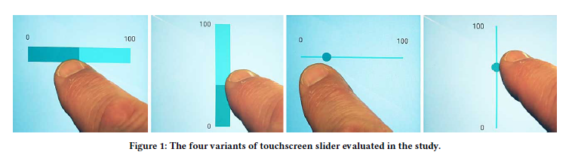

【Tasks】：

Compare the four different visual presentation methods of the touch screen slider on the smartphone with or without thumb, and horizontal and vertical directions. We found that both the visual style and the orientation of the touch screen slider affect the accuracy of the input value. In addition, we found systematic error patterns in the slider input range.

【Contributes】:

(1) Quantifying the accuracy with which users can input data on touchscreen sliders

(2) Identifying performance differences between horizontal and vertical sliders

(3) Describing the effect of two common visual styles on users’ performance

【Slider Functionality and Terminology】：

• **Track**, showing the range available for user selection. The track may run horizontally or vertically and the smallest value is located on the left (for left-to-right language settings) or bottom of the track respectively. In this paper we refer to sliders with an inclusive range of range 0 to 100.

• **Thumb**, which moves along the track, indicating the selected value through its position.

• **Optional additional visual elements**, such as tick marks on the track or a value label, numerically indicating the current position of the thumb.

• **Touch area** - the area that must be pressed such that the slider captures the touch event - once captured, the dragging finger can freely move anywhere on the touchscreen whilst moving the slider thumb.

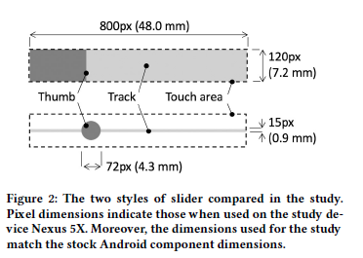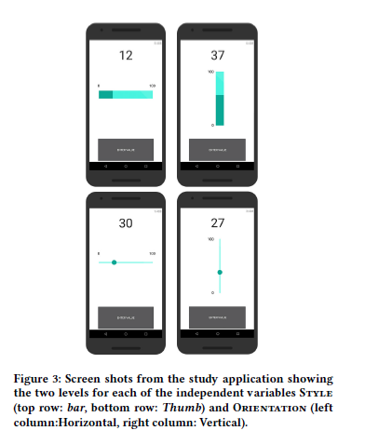

【VAS】：visual analogue scale

【hypthoses】：

**H1：** As prior works on touchscreen interaction [9, 11] have identified the propensity for visualization affecting inter-action, we set Hypothesis 1 (H1): The visual appearance of the slider thumb will influence slider performance.

**H2：**For paper-based VAS there has been much work investigating the influence of orientation e.g., [17, 19, 20]. Thus it is of interest to examine if similar effects are visible in touchscreen implementations. Additionally, Matejka et al.’s [13] work on visualization effects, whilst limited to horizontal orientation, highlights the need to inves-tigate vertical orientations. Hence we set Hypothesis 2 (H2): The orientation of the slider, horizontal or vertical, influences slider performance.

**H3：**Prior work, for example Matejka et al. [13] have identified systematic distortions across the input range of sliders. Aiming to validate this for touchscreen imple-mentations we set Hypothesis 3 (H3): There is a sys-tematic error in slider input across the range of input targets.

【Experiments】：

Device：

Nexus 5X

Independent Variable：

**Style**

**Orientation**

Results：(Detail in Paper)

【Setting Error and Bias】 【Task Completion Time】 【Interaction Style】 【Error Trend Estimation】

 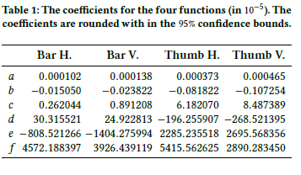

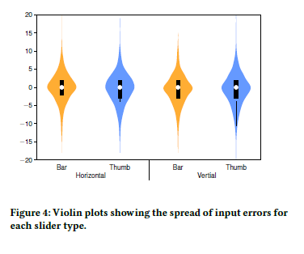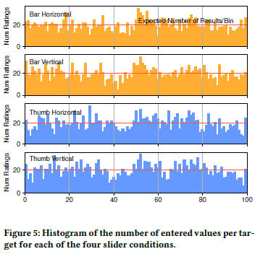

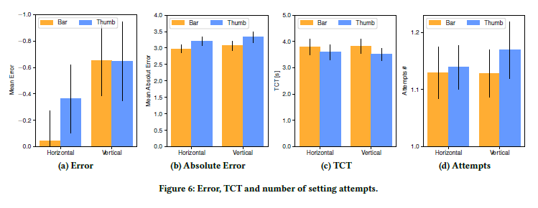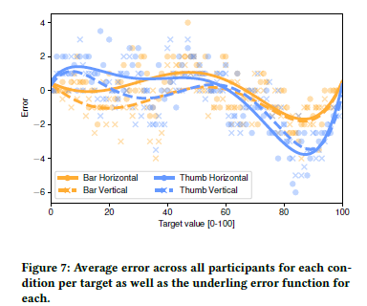

Discuss:

**H1-> Support：**The thumb slider is significantly faster than the slider. We think there are two possible reasons. First, because the visible thumb provides higher affordability and the preferred mode of slider interaction, the user presses the thumb before starting to drag. Here, the larger visual target area presented by the thumb in the thumb state will result in a faster initial compression than in the strip state, see, for example, Henze et al. [9]. The second contributor may be that the larger thumb introduces a sense of ambiguity in the setting, which encourages users to adapt to the "close enough" value. This is usually supported by the findings of Greis et al. [8], they entered uncertain data when studying sliders.

**H2-> Support：**We were also able to test our second hypothesis (H2): slider orientation affects performance. Here we re-report that the vertical direction introduces more offset distortion to the input than the horizontal direction. No difference was found in the interaction time between the two directions.

**H3-> Support：**We found significant differences in offset errors at different positions within the slider range, which validated our hypothesis (H3). As we pointed out in the (H1) discussion, this is most likely due to the participant placing a slider relative to a reference point, such as the end of the track or the midpoint of the track. Participants' reading directions from left to right may account for larger errors in the range of 70 to 95 [5], while participants have lower accuracy in estimating backwards from the end of the 100 track.

【Conclusion】：

When the user enters data, the design and orientation of the touch screen slider affects the offset error. Overall, it was found that a slider designed without a thumb and placed horizontally works best and has a small offset from the input value. However, although more offset is introduced, the slider with a visible round thumb is faster to set up. The system distortion of the input value and the target value is determined, which has the greatest influence on the range of 70% to 95% of the slider trajectory.

【Important Reference】:

Lars Lischke, Paweł W. Woźniak, Sven Mayer, Andreas Preikschat, and Morten Fjeld. 2017. Using Variable Movement Resistance Sliders for Remote Discrete Input. In Proceedings of the 2017 ACM International Conference on Interactive Surfaces and Spaces (ISS ’17). ACM, New York, NY, USA, 116–125. https://doi.org/10.1145/3132272.3134135

Justin Matejka, Michael Glueck, Tovi Grossman, and George Fitzmau-rice. 2016. The Effect of Visual Appearance on the Performance ofContinuous Sliders and Visual Analogue Scales. In Proceedings of the 2016 CHI Conference on Human Factors in Computing Systems (CHI ’16). ACM, New York, NY, USA, 5421–5432. https://doi.org/10.1145/ 2858036.2858063

Juan Rosso, Céline Coutrix, Matt Jones, and Laurence Nigay. 2018. Simulating an Extendable Tangible Slider for Eyes-free One-handed Interaction on Mobile Devices. In Proceedings of the 2018 International Conference on Advanced Visual Interfaces (AVI ’18). ACM, New York, NY, USA, Article 16, 9 pages. <https://doi.org/10.1145/3206505.3206510>

Jane Scott and EC Huskisson. 1979. Vertical or horizontal visual ana-logue scales. Annals of the rheumatic diseases 38, 6 (1979), 560.